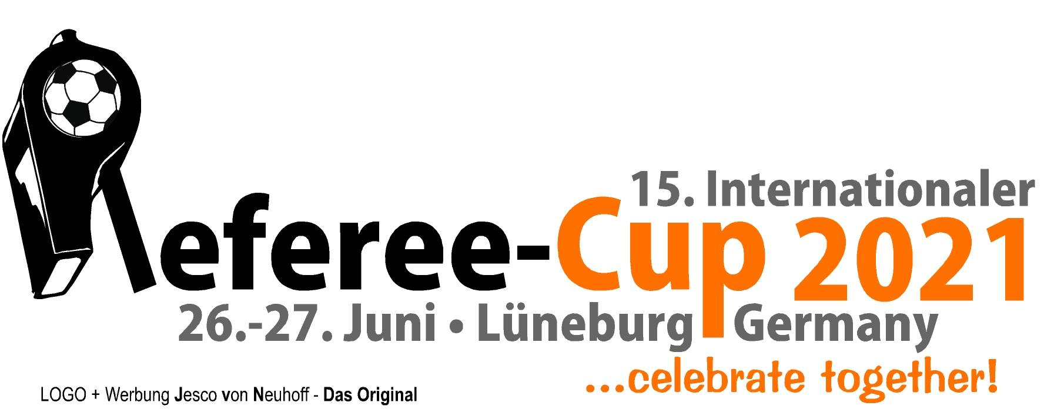

15th International Referee Cup
Lueneburg/Germany - June 26th + 27th 2021

June 23rd (Wednesday)
? Arrival of the tournament referees
Lunch N. N.
Dinner Club’s pub „FairPlay“

June 24th (Thursday)
Morning City tour of Lueneburg
Lunch N. N.
Afternoon Team building at a trolley bike ride
Dinner N. N.

June 25th (Friday)
10:00 am Referee Seminar Part 1
Lunch N. N.
04:00 p.m. Referee seminar part 2 with local referees
Dinner N. N.
07:30 p.m. Monthly meeting Lueneburg Referee Association

June 26th (Saturday)
Lunch Snacks in the VIP area
02:00 p.m. Siegfried-Koerner-Stadium - Referee Cup 1st day
Dinner Club’s pub „FairPlay“ - tournament offer
07:30 p.m. Party

June 27th (Sunday)
10:00 a.m. Siegfried-Koerner-Stadium – Referee-Cup 2nd day
Lunch Snacks in the VIP area
4:30 p.m. End of Referee Cup
5:30 p.m. Dinner at „Anno 1900“ – the 3rd halftime with organizers, referees and guests

15th International Referee Cup
Lueneburg/Germany - June 26th + 27th 2021

June 28th (Monday)
10:00 a.m. Hamburg/Berlin/Hanover
Lunch N. N.
Dinner ? in Lueneburg

June 29th (Tuesday)
11:00 a.m. Barsinghausen (with lunch)
05:00 p.m. Snowdome Bispingen (?)
Dinner ? in Lueneburg

June 30th (Wednesday)
? Departure of the tournament referees

Other possible sightseeing options:

- Heide-Park Soltau
- Volksparkstadion Hamburg (WC stadium)
- Boat lift Scharnebeck
- and more…

A presence from Thursday (June 24th), 12:00 p.m. to Monday (June 28th), 10:00 a.m. is desirable.

