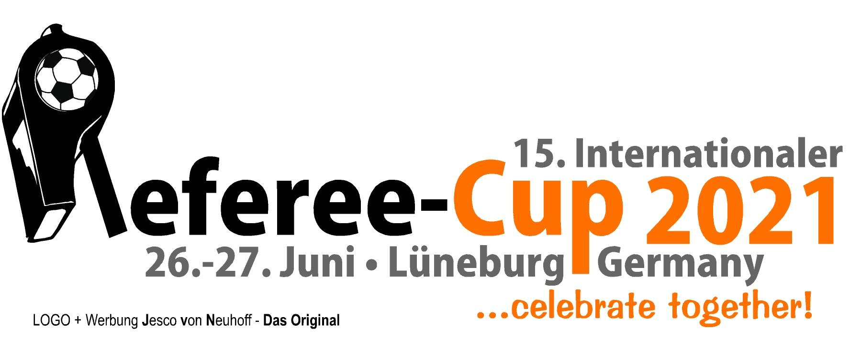

15th International Referee Cup
Lueneburg/Germany - June 26th + 27th 2021

We are pleased to invite up to ten referees to be part of the referee family and to officiate the matches at the 15th International Referee Cup of SV Eintracht Lueneburg/Germany - very fond of FIFA and Premier League Referees, as well as appropriate FIFA Referee Assistants - women and men.

We offer the following:

Travel:
- Support to get the German visa (if necessary)
- NOT included: flight tickets (next airports are Hamburg, Hanover, Bremen, Berlin)

Stay:
- All transfers in Germany
- 7 days/6 nights: accommodation + meals (breakfast, lunch, dinner)
- Assistance for a possible further holiday trip in Germany/Europe

Program:
- Referee course with local referees (Coach Günther Thielking – nationwide DFB referee instructor)
- Visiting a school sports session (if possible)
- Private invitations for dinner (if available)
- Training (if desired)
- Press interviews
- Sightseeing program (Hamburg, Hanover, Berlin - if possible -)
- Sightseeing tour through and shopping possibility in Lueneburg

Tournament:
- Officiating all matches of the 15th Referee Cup
- Small fields (half the size of a real soccer ground)
- No offside!
- Refreshments all days
- Participation at the „Player’s Night“ on Saturday for free
- Contact to referees from all over the world

